# 2. Data and Method

The research workflow is summarized in Fig. The Landsat archive was used to mapping the urban development from 1990 to 2019 with a 3-year interval (paper-1). Digital Elevation Model (DEM) and slope were used to improve the projection performance. All raster data had the same 30m resolution and were concatenated as the input image. The training samples were randomly cropped from the training image (i.e., image with an earlier date urban map) with a size of 256 × 256 (i.e., the width and heights of the parcel were 256 pixels). The UNET was trained on these samples and then coupled with the base image (i.e., image with a later urban map) to produce the transition potential map (i.e., image where each pixel indicating the potential to be urban lands in the future). Lastly, a threshold was determined to binarize the transition potential map into a projection map where pixels with the value 1 as the projected urban land and 0 as non-urban land.

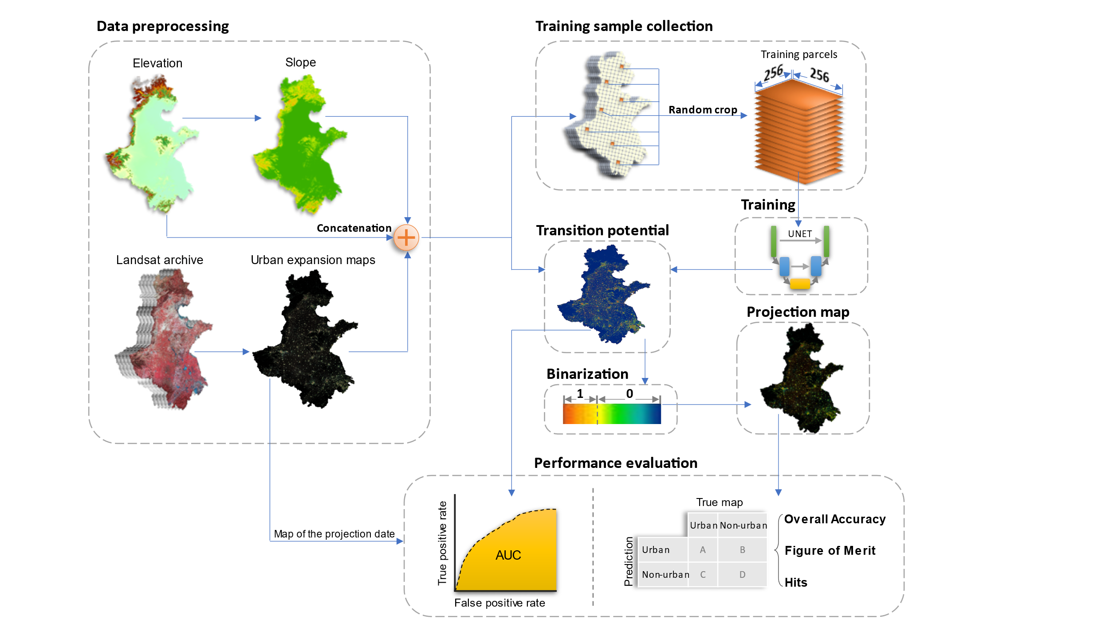

## 2.1 Data preprocessing

The raster data used in this study were summarized in table. The urban dynamics maps were obtained from (paper-1). This product spanned from 1990 to 2019 with three-year intervals and had a consistently high accuracy of > 94% across years because the use of temporal features successfully delineates urban land from fallow cropland and a consistent check removed unreasonable urban developments (ref). The digital elevation model (DEM) was obtained from the Shuttle Radar Topography Mission (SRTM) and the slope data was derived from the DEM. The DEM and slope were used to assist the UNET to learn urban development patterns in complicated topology conditions, which have been proven effective in previous studies (ref).

|  |  |  |  |
| --- | --- | --- | --- |
| **Data Type** | **Source** | **Resolution** | **Time** |
| Urban dynamics | Wang et. al. | 30m | 1990-2019 |
| DEM | SRTM | 30m | 2000 |
| Slope | Derived from DEM | 30m | 2000 |

## 2.2 Control sample collection

Control samples were collected at the Google Earth Engine platform for its parallel computation advantages (ref). The *neighborhoodToArray* module was used to randomly crop parcel samples from the training image. We set the neighborhood size to 256 following common data science practices (ref) and collected 25,000 samples, among which 20,000 were used for the model training and the rest 5,000 for validation.

## 2.3 Training the UNET

UNET is a deep convolutional network that is commonly used for image segmentation (ref). Down-sampling, up-sampling, and skip-connections are the primary components for UNET (ref). The down-sampling enables UNET to extract the general context of the input image, the up-sampling refined the context pattern to precise shapes, and the skip-connections balance the generalization of down-sampling and the localization of up-sampling (ref). The output of the UNET is an image that has the same size as the input data, where each pixel indicating the probability belonging to a preset category.

The UNET was trained on parcel images with the size of 256 × 256 pixels (fig). Each training image parcel includes a 3-layer input data (an early data urban map, a DEM, and a slope map) and a single-layer target data (a later data urban map indicating the true urban expansion). The 3-layer input data, during training, will be transformed to the size of 8 × 8 pixels after 5 down-sampling processes, and then converted to a single-layer output image with the original size of 256 × 256 pixels over another 5 up-sampling operations. The mean squared error (MSE) was used to measure the difference between the output and the target image. A total of > 31 million parameters were involved in the training process and the derivative of each parameter to the MSE was calculated via a backpropagation process. The parameters were updated according to the derivatives: if increasing a parameter would increase the MSE, then this parameter will be decreased, and vice versa. We iterated this training process for 200 epochs (an epoch refers to the UNET seeing all 20,000 training samples) because the model will overfit the training samples for more training epochs. The validation samples had the same structure as the training sample but did not update the model parameters and were used to assess the UNET on unseen data.

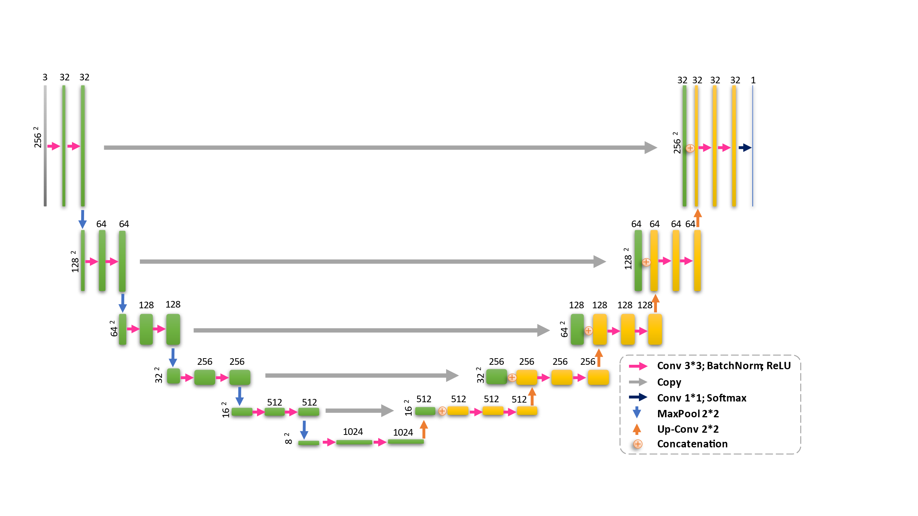

## 2.4 Producing the transition potential map

The base image was split into image parcels, then supplied to the trained UNET to produce the separate output, and then mosaiced into the transition potential map. The pixel values of this map range from 0 to 1 and indicates the probability to be an urban pixel in the projection date. To reduce the “edge effect”, the split image parcels were buffered with 32 additional pixels at each edge compared to training image parcels, and the buffer was removed before been mosaiced into the final transition potential map (ref). Although the UNET was trained on image parcels of 256 × 256 pixels, it can be applied to the buffered image parcels of 320 × 320 pixels (i.e., the original size of 256 plus two buffer zone of 32) (ref).

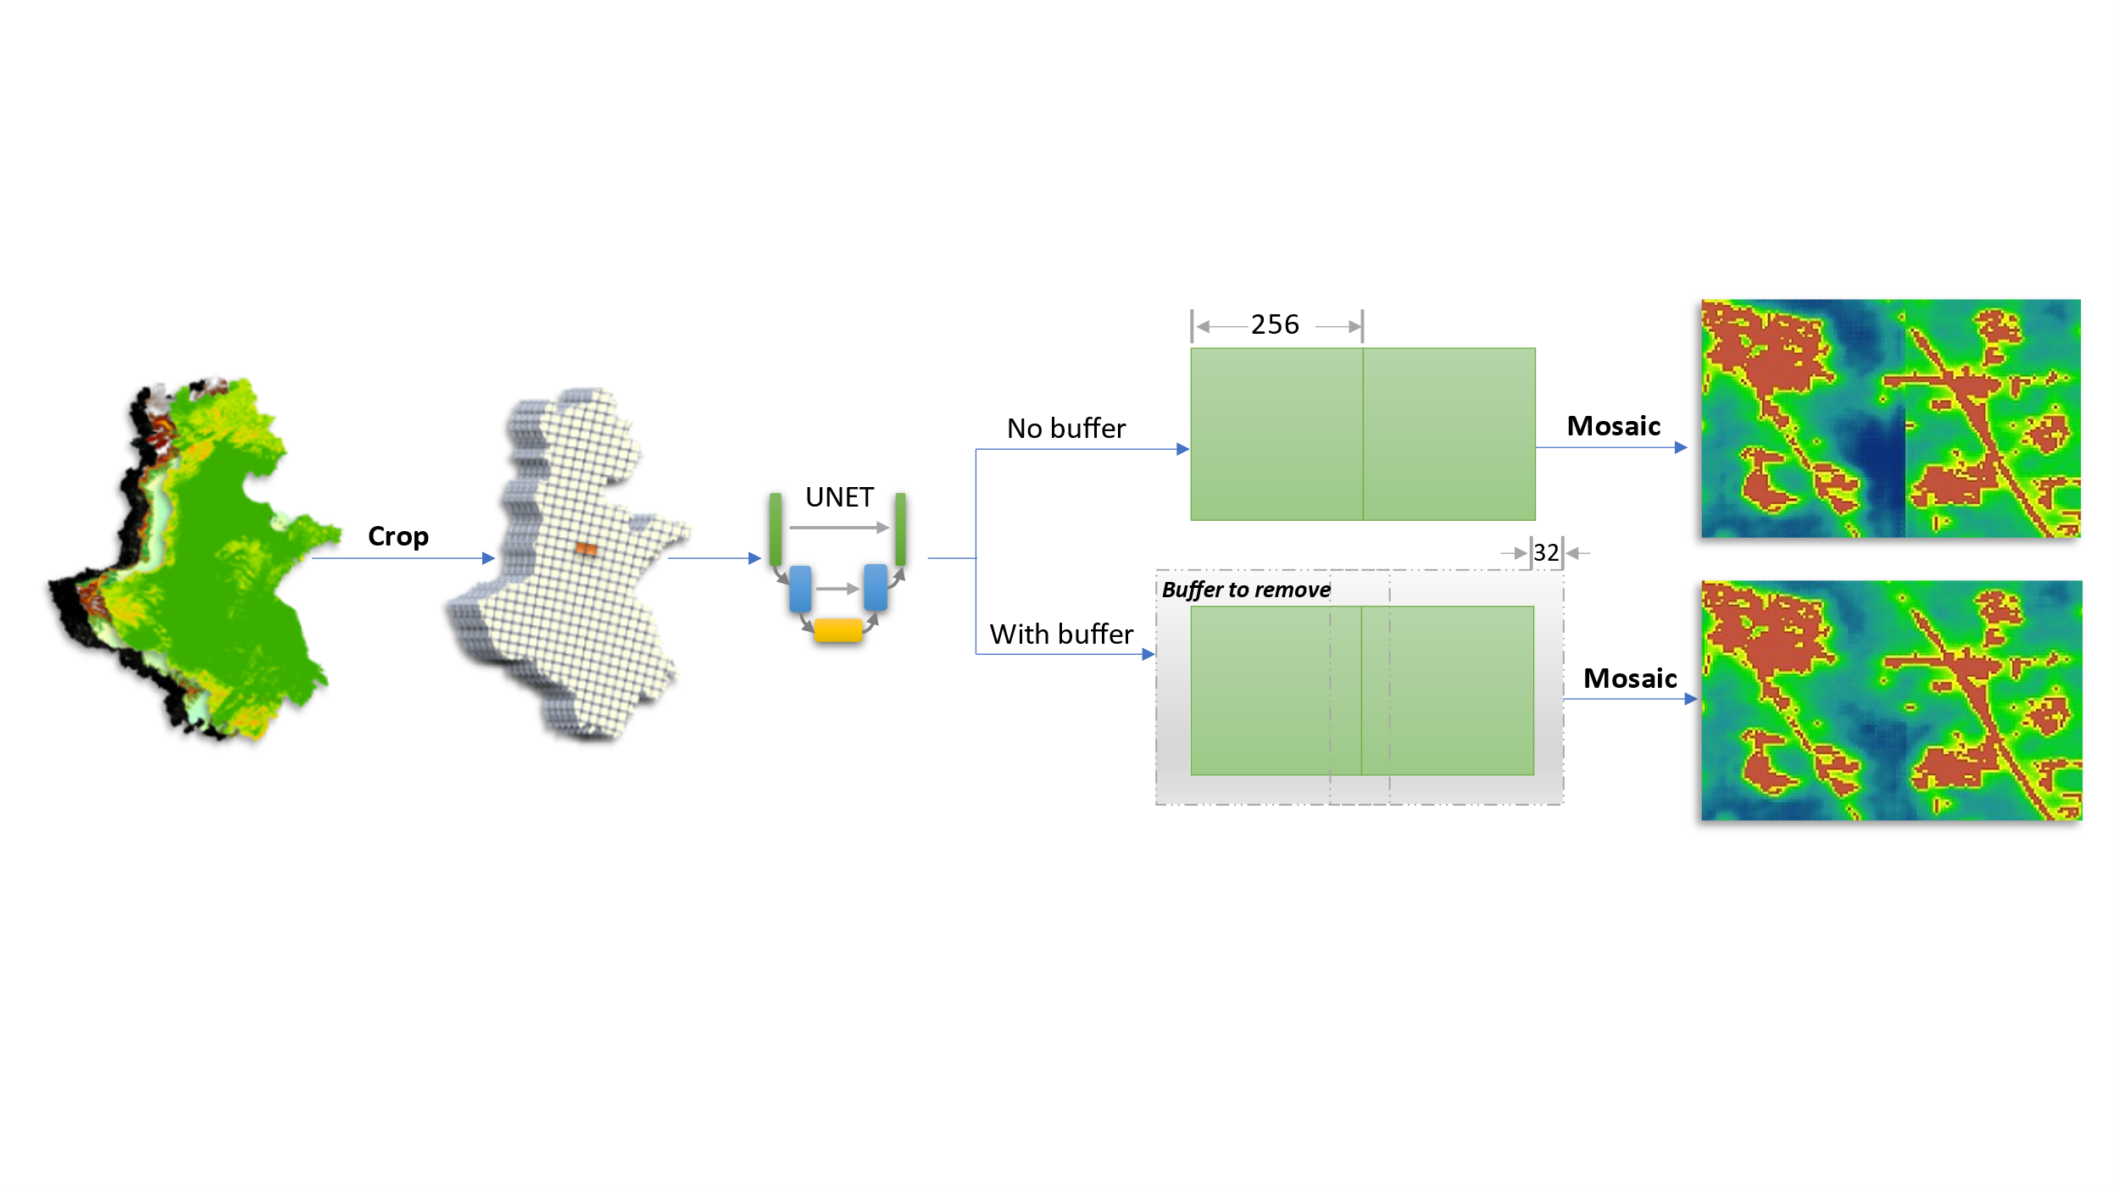

## 2.5 Producing the projection map

The projection map was created by binarizing the transition potential map. We computed the pixel count of the transition potential map at an interval of 0.0001, then accumulated these pixel counts from the highest value to the lowest, and lastly selected the accumulated value that was the closest to the urban pixel count of the urban map in the projection date as the threshold to binarize the transition potential map.

We validated the UNET model using the historical urban maps and projected to future urban extents in 2030. The validation took the urban maps of 1993-1995 and 2005-2007 to train a UNET model, then applied this trained UNET model on the urban map of 2005-2007 to project the urban map of 2017-2019. The true urban map of 2017-2019 was used to assess the performance of the projection. Similarly, we used the urban map of 2005-2007 and 2017-2019 to train another models that projected the urban map to 2030. The urban area of 2030 was determined by regressions on the historical urban area: a linear, a quadratic, and a cubic fitting were applied on the past urban areas to extrapolate the urban area in 2030. These urban areas were then adopted as thresholds to binarize the transition potential map based on 2017-2019 and produced three urban maps in 2030.

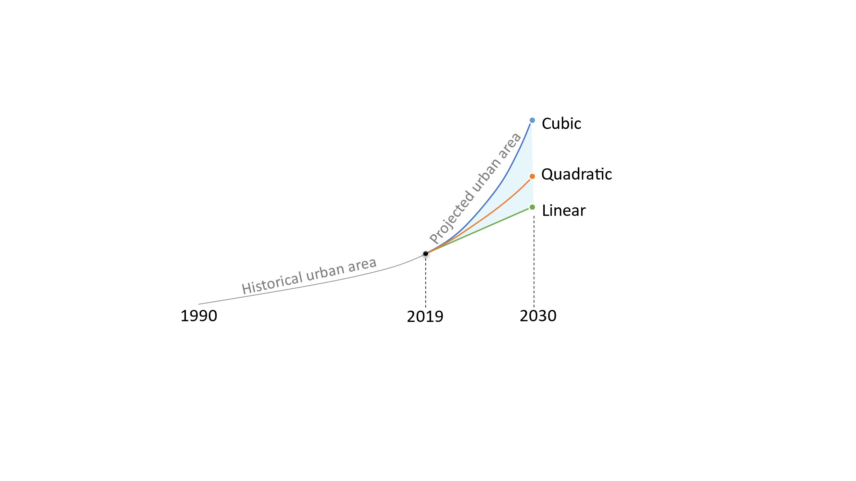

## 2.6 Assessing the performance of the projection

The transition potential map was assessed using the area under the curve (AUC) of the receiver operating characteristic (ROC), while the projected map was evaluated via map-overlay metrics and landscape metrics. The AUC ranges from 0.5 to 1 and indicates models from totally random to perfect (ref). In this study, as the threshold to binarize the transition potential map increased from 0 to 1, the portion of simulated urban pixels but actual non-urban to total pixels (e.g., false positive rate) and the portion of correctly simulated urban pixels (e.g., true positive rate) changed. The ROC is the line that connects all points in this plane from left to right and the AUC is the region between this line and the x-axis.

The map-overlay metrics selected in this study is overall accuracy (OA), figure of merit (FoM), and the hit rate. The hit refers to correctly predicted urban pixels (A), the false alarm refers to the incorrectly predicted urban pixels (B), the miss is the incorrectly predicted non-urban pixels (C), and the correctly rejection is the corrected predicted non-urban pixels (D). The map-overlay metrics were calculated as bellow:

|  |  |  |
| --- | --- | --- |
|  | OA = (A + D) / (A + B + C +D) | (1) |
|  | FoM = A / (A + B + C) | (2) |
|  | Hit rate = A / (A + C) | (3) |